 | Safeguarding policy
 | 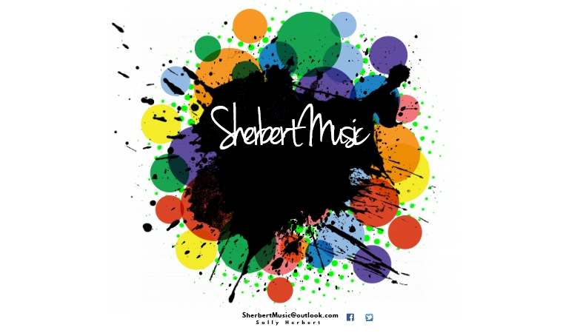
August 2018 | Safeguarding and Wellbeing

Safeguarding policy

Safeguarding
SherbertMusic is committed to safeguarding and promoting the welfare of children and young people and expects all staff to share this commitment.
SherbertMusic has a legal duty to recognise and respond appropriately to:
• Significant changes in the children’s behaviour
• Deterioration in their general well-being
• Unexplained bruising, marks or signs of possible abuse
• Signs of neglect
• Comments children make which give cause for concern
If you recognise one of the above for a child, the severity and circumstance will dictate your
actions. The important thing for you is to do something and not ignore it. We will create an
environment to make the children be and feel safe. Any suspicions or allegations of abuse will be
taken very seriously and they will be acted on quickly and correctly by following the procedure set
by the Local Safeguarding Children’s Board (LSCB)
Four Categories of Abuse – This list is not exhaustive
All Types of abuse can occur in all types of homes, across all social and income groups.
- Neglect Definition
- Longstanding and/or severe neglect
- Effect on the Childs development
- Non-organic failure to thrive
Signs/Symptoms
- Constant Hunger, Tiredness, stealing or scrounging
- Poor personal hygiene, or inappropriate clothing for weather or activities. Untreated medical problems
- Low self-esteem, poor social relations
- Physical Definition
- Deliberate injury to the child – allowing injury. Beyond ‘reasonable’ chastisement. Poisoning, including alcohol
- Withholding drugs or apparatus
- Both the use of an implement e.g. a belt or a physical strike that leave a mark are illegal
Signs/Symptoms
- Unexplained or untreated injury, especially if there is repetitive refusal to discuss injuries, and
untreated injuries. Shrinking from physical contact
- Fear of returning home, undressing, or medical help. Aggression or bullying
- Unexplained pattern of absences which may server to hide bruises or other physical injuries
- Sexual Definition
Sexual exploitation of any kind including watching others and viewing pornographic material
Signs/Symptoms
- Sexual awareness inappropriate to the child’s age, through drawings, games, vocabulary
etc
- Frequent public masturbation
- Attempts to teach other children about sexual activity. Aggressiveness, anger, anxiety, fearfulness. This is a short summary, there are other signs, individual to certain children
- Emotional Definition
- Must be persistent
- Must undermine the child’s sense of self worth
- Might reflect poor parenting skills
- Includes witnessing domestic violence of primary carer
Signs/Symptoms
- Continual self-depreciation, self-harm or mutilation. Inappropriate response to painful situations
- Compulsive stealing/scrounging
- Air of detachment, social isolation or desperate attention seeking behaviour, depression or
withdrawal.
- Eating problems, either overeating or a lack of appetite

Child Sexual Exploitation CSE
Involves exploitative situations where a child, male or female, receives something from an adult as
a result of engaging in sexual activity. This can be seemingly ‘consensual’ relationships to
serious organised crime gangs. There will be an imbalance of power where the perpetrator holds
power over the victim. Technology is often used. This is a serious crime.
Female Genital Mutilation FGM
This is illegal and a form of child abuse. It involves a procedure to remove all or some of the
female genitalia or any other injury to these organs. It is a legal duty to report known cases to
the police.
Forced Marriage
Is illegal and a form of child abuse. A marriage entered into without the full and free consent of
one or both parties, where violence or coercion is used.
Dealing with a Disclosure
1. Listen and stay calm. Do not condemn the abuser, do not judge, do not make promises you can’t keep
2. Reassure them. Tell them that you believe them. Tell them that it happens to others and that
they are brave to tell you.
3. Stay with them. If you can ‘ground’ them (“grounding” means to draw the child
back to a more comfortable state of mind through things like normal conversation
e.g. what activities have you done today, what’s your favourite TV programme)
4. Accurately record the child’s words. Make it clear whether it is a fact, opinion or hearsay.
5. Report it to your relevant manger or head office as soon as possible; they will know the right
procedure to follow. In some cases, they will speak to the parents first or
report to the local safe guarding children’s board.
6. If a third party expresses concern that a child is being abused, we will encourage them to
contact Social Care directly. If they will not do so, we will explain that the Club is obliged to
and the incident will be logged accordingly.
If you have any concerns about a child’s welfare at your club, do not keep it to yourself. Write it
down and take advice.

Protecting yourself
Part of safeguarding is also to protect yourself from allegations and to ensure your actions are
not misinterpreted by anyone. Do this by observing the following:
• Avoid being alone with a child
• Take a register of which children are with you for each session, noting the time of the session.
• If you take a child somewhere e.g. an empty room, do not enter with them, wait outside. If you
have to enter the room, it’s vital you keep all doors open.
• Do not play-fight
• Children should not be encouraged to sit on your lap
• Challenge any child using ‘bad’ language
• Never let children touch themselves or others inappropriately in any form
• Never let a child’s allegation go unchallenged, unrecorded or not acted on
• Never do personal things for children that they are capable of doing themselves. Encourage
children to help each other.
• Do not build ‘special’ relationships with individual children
• You must not, before, during or after your employment make or accept any contact with a child or a friend of a child you know through your work with SherbertMusic or through social networking
websites.
• Any images of children taken on site must only be of those children whose parents allow photos to be taken. Staff should not take any photos off site.
• Any images taken must be appropriate.
• It is each individual staff’s personal responsibility to delete any images from cameras, phones
and recording devices.
• Images must not be published elsewhere without the authorisation of parents.
Whistle Blowing
SherbertMusic will not accept or condone any behaviour by Staff or other adults associated with the Club that is contrary to our Policies and Procedures. We will actively encourage and fully support the reporting of such behaviour. We will do this by:
• Promoting an environment of mutual respect, trust and open communication.
• Promoting an environment that is free from bullying, harassment and discrimination.
• Treating everyone equally and fairly, with dignity and respect and by valuing individual
differences.
• Ensuring that the quality of the work of each staff member/volunteer is effectively monitored as
well as the work of the club as a whole.
• Ensure that procedures are in place for reporting unacceptable behaviours/practices.
• Provide staff with a number of ways to report including a confidential form on our website.
• Actively supporting staff/volunteers that ‘blow the whistle’ both during the
investigation and after, and in line with the relevant legislation.

Allegation against a professional
If there is a serious allegation of abuse made against you, SherbertMusic will have to suspend you
whilst the investigation is carried out. This is to protect all parties, including you. You should:
• Stay calm
• Follow the manager’s instructions
• Co-operate with questions and enquires
• Seek advice –citizens advice bureau.
• Not confront the accuser
• Not speak with your ‘victim’
• Be supported through the process by a designated person.
Good practice guidelines
All personnel should be encouraged to demonstrate exemplary behaviour in order to promote
children’s welfare and reduce the likelihood of allegations being made. The following are common
sense examples of how to create a positive culture and climate.
Good practice means:
• Always working in an open environment (e.g. avoiding private or unobserved situations and
encouraging open communication with no secrets).
• Treating all young people/disabled adults equally, and with respect and dignity.
• Always putting the welfare of each young person first, before winning or achieving goals.
• Building balanced relationships based on mutual trust which empowers children to share in the
decision-making process.
• Making activities fun, enjoyable and promoting fair play.
• Being an excellent role model – this includes not smoking or drinking alcohol in the company of
young people.
• Giving enthusiastic and constructive feedback rather than negative criticism.
• Recognising the developmental needs and capacity of young people and disabled adults – avoiding excessive training or competition and not pushing them against their will.
• Keeping a written record of any injury that occurs, along with the details of any treatment
given.
Practices never to be sanctioned
The following should never be sanctioned. You should never:
• Engage in rough, physical or sexually provocative games, including horseplay
• Allow or engage in any form of inappropriate touching
• Allow children to use inappropriate language unchallenged
• Make sexually suggestive comments to a child, even in fun
• Reduce a child to tears as a form of control
• Fail to act upon and record any allegations made by a child
• Do things of a personal nature for children or disabled adults, that they can do for themselves

Use of mobile phones and cameras
Photographs will only be taken of children with their parents’ permission. Photos will only be shared on the SherbertMusic facebook page.
Changing
Under 8’s – Ensure there is always 2 members of staff in the changing area and that you can see
each other at all times. Staff should not dress or dry children but support them in doing so
themselves. Wait until all children are ready.
Over 8’s – Staff should wait outside of the changing rooms. If there is a disturbance that warrants
entry, avoid entering alone and never enter alone if there are less than 3 children left.
Toilet Supervision
Under 8’s – Children will be escorted to the toilets and staff will remain outside the door to
assist if help is requested.
Over 8’s – All children will ask to use the toilet facilities. Staff will monitor numbers and
ensure children return to their play in the appropriate location
Prevent Duty
SherbertMusic recognises its duty to prevent children and families being drawn into terrorist or
extremist behaviour and employ the following methods:
• Follows the guidance in the government document ‘Prevent duty guidance for England and Wales 2015’
• Staff have access to Prevent training
• We value all children and their families equally
• We promote the development of positive attitudes and behaviours to all people, whether they are different from or similar to themselves
• We have a commitment to challenging prejudice
• Report any concerns about children, staff or families to the relevant authorities
If you are worried about sharing concerns about abuse you can contact the police direct, or the NSPCC Helpline on 0808 800 5000, or Child line on 0800 1111.

